AIM:
Compare Traditional and low code
INTRODUCTION TO TRADITIONAL APPROCH:
The Traditional Approach is one of the earliest methods used in the study of management and organizational theory. It focuses on improving efficiency, establishing clear organizational structures, and defining roles and responsibilities. This approach emphasizes formal rules, division of labor, hierarchy, and centralized decision-making to achieve organizational goals.
The traditional approach is mainly based on the contributions of pioneers such as Frederick Winslow Taylor, Henri Fayol, and Max Weber. Their ideas laid the foundation for modern management practices by promoting specialization, standardization, and systematic planning.

Key Features
- Clear division of work and specialization.
- Defined hierarchy of authority.
- Formal rules and procedures.
- Centralized decision-making.
- Emphasis on efficiency and productivity.

Advantages
- Increases organizational efficiency.
- Clearly defines duties and responsibilities.
- Promotes discipline and order.
- Simplifies supervision and control.

Disadvantages
- Ignores human and social aspects of employees.
- Rigid and less adaptable to change.
- Limits employee creativity and participation.
- Can reduce motivation due to excessive control.
INTRODUCTION TO LOW CODE APPROCH :
The Low-Code Approach is a modern software development method that enables applications to be built with minimal hand-written code. Instead of writing complex programming logic from scratch, developers and business users use visual interfaces, drag-and-drop components, pre-built templates, and automated workflows to create applications quickly and efficiently.
Low-code platforms are designed to accelerate application development, reduce development costs, and make software creation accessible to both professional developers and non-technical users (often called citizen developers). While some coding may still be required for advanced features or custom integrations, most common tasks can be completed using visual tools.

Key Features
- Visual drag-and-drop development environment.
- Minimal manual coding.
- Pre-built templates and reusable components.
- Rapid application development and deployment.
- Easy integration with databases and external services.
- Collaboration between business users and developers.

Advantages
- Faster application development.
- Lower development and maintenance costs.
- Increased productivity and efficiency.
- Easier for non-programmers to build applications.
- Simplified updates and maintenance.
- Faster response to changing business requirements.

Disadvantages
- Limited flexibility for highly customized applications.
- Dependence on the chosen low-code platform.
- Potential vendor lock-in.
- Performance limitations for very large or complex applications.
- Licensing costs for enterprise platforms.
DIAGRAM FOR STAGES IN TRADITIONAL AND LOW CODE :

1. Stages in the Traditional Approach

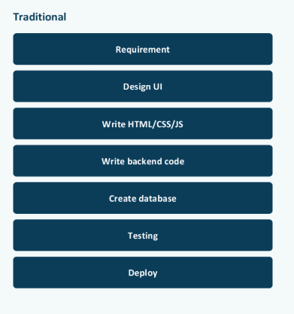

2. Stages in the Low-Code Approach

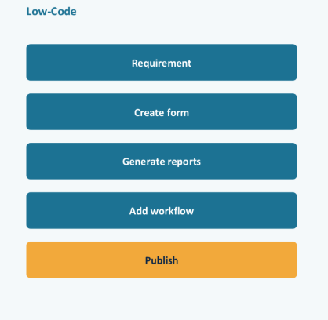

Comparison Between Traditional Approach and Low-Code Approach
Traditional Approach | Low-Code Approach
Requires extensive manual coding. | Requires minimal manual coding using visual tools.
Development takes more time. | Development is faster and more efficient.
Requires skilled programmers for most tasks. | Can be used by both professional developers and citizen developers.
Coding is done from scratch. | Uses drag-and-drop components and pre-built templates.
Higher development and maintenance costs. | Lower development and maintenance costs.
Changes and updates require significant coding effort. | Changes can be made quickly with minimal coding.
Better suited for highly complex and customized applications. | Best suited for business applications, workflow automation, and rapid prototyping.
Longer testing and deployment cycles. | Faster testing and one-click deployment.
Offers maximum flexibility and control. | Flexibility may be limited by the platform's capabilities.

